ARUN GAS

VOT & LOT Installations

VOT (Vapour – Off – Take)
- VOT Cylinders are the normal conventional type of cylinders which you would find in your homes, restaurants and other small commercial establishments These type of cylinders were introduced in India after independence with a view to provide LPG for cooking in homes.
- In these type of cylinders, the vapour is converted naturally inside the cylinder is discharged out through a VOT cylinder valve and used for usage applications.
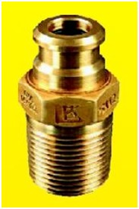
VOT Cylinder Valve
- The rate at which liquid LPG inside the cylinder is naturally converted into LPG vapour and discharged for usage is around 0.4 to 0.7 kg/hr.
- These type of cylinders are often required in household kitchens, commercial kitchens, restaurants, canteens, small industries, etc in multiple quantities connected in series for higher off-take where there is a higher consumption rate of LPG.
The standard configurations and schematic views of a VOT cylinder bank according to the consumption pattern of the user is as below:
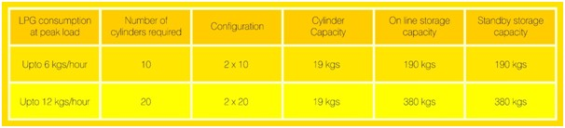
Schematic Views of VOT Cylinder Installation for Commercial Kitchen
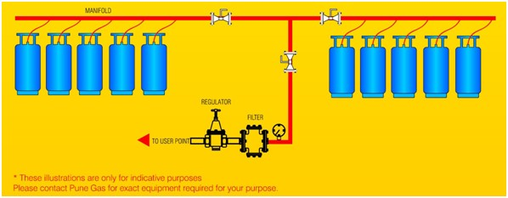
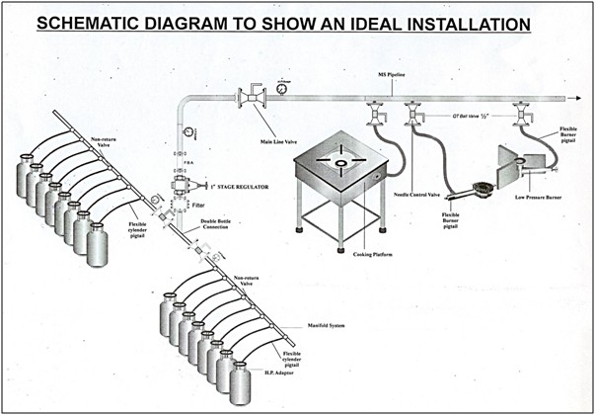

LOT (Liquid – Off – Take)
- LOT Cylinders were introduced in India in view of shortage of space and availability for a VOT Multi Cylinder Bank, as LOT cylinders save space in places of high consumption like Star Hotels, Small, Medium and Large Scale Industries where installation of a bulk LPG tank is not possible.
- In case of LOT, liquid LPG will be drawn instead of conventional vapour, using a liquid out-take valve which is transferred to a specially designed vapouriser to convert it into gas form to be used for the usage application.
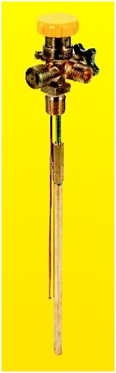
LOT Cylinder Valve
- The rate at which liquid LPG inside is the cylinder is discharged is 4 kg/hr.
- Thus, the quantum of cylinders required is reduced and the number cylinders can be connected in series as per LPG consumption and required stock.
The standard configurations and schematic views of a LOT cylinder bank according to the consumption pattern of the user is as below:
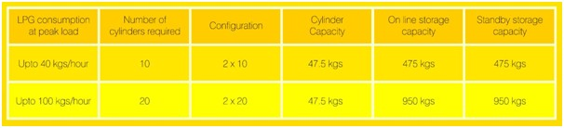
Schematic View of LOT Cylinder Installation for Industries
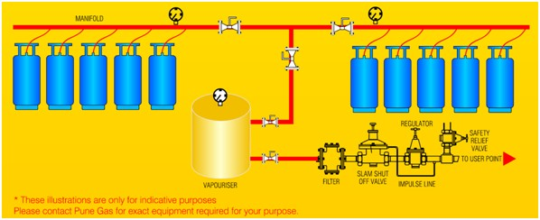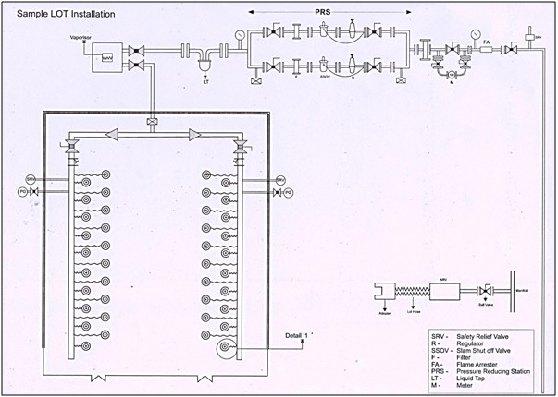

Advantages & Benefits of LOT Installations:
1. A LOT cylinder bank substantially reduces:
a. Space required for storage of cylinders.
b. Cylinder handling in Gas Bank area.
c. The residual gas loss that occurs in VOT cylinders, which returns unused.
2. Absolutely safe and recommended where LPG consumption is relatively high in places like hotels and industries and installing a bulk tank is not an option.
3. Gas bank sizing depends on consumption of LPG, per hour and per day, and not on vapour conversion capacity of cylinders. Using lesser number of cylinders results in reduction in size of cylinder bank and reduced cylinder handling.
4. No residual amount returned unused in the cylinder, thus ensuring zero loss of LPG and increased savings for consumers.

